|  |  |
| --- | --- |
| **Server & Cloud Security**  Diploma in CSF/IT  Oct 2022 | Week 4 |
| Tutorial |
| **Cloud Security Basics** | |

1. Briefly discuss the key features / advantages of SaaS model.

|  |
| --- |
|  |

1. Briefly discuss the key features / advantages of PaaS model.

|  |
| --- |
|  |

1. Briefly discuss the key features / advantages of IaaS model.

|  |
| --- |
|  |

1. Referring to the “Division of Responsibility” diagram by Microsoft, discuss the differences in responsibilities when your workload is hosted on Software as a Service (SaaS), Platform as a Service (PaaS), Infrastructure as a Service (IaaS), or in an on-premises datacenter.

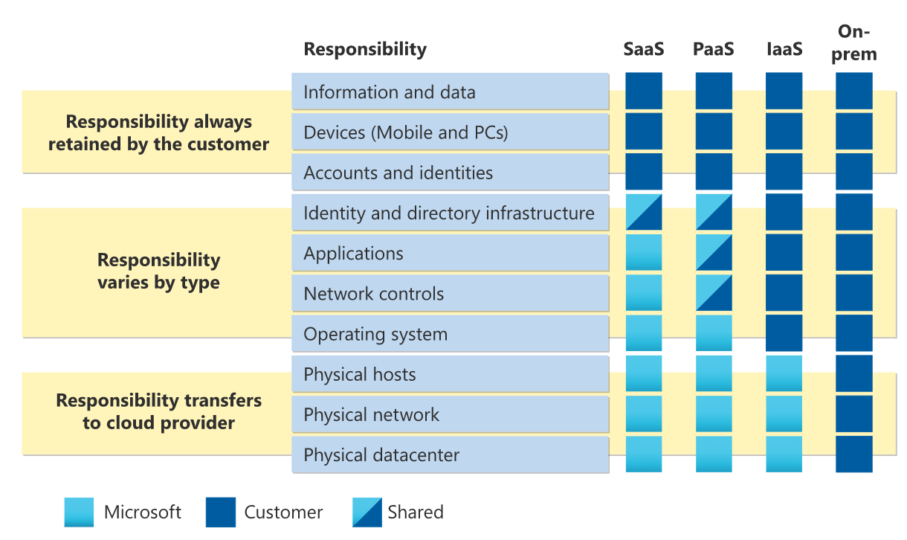

|  |
| --- |
|  |

- The End -